Date:

Lab Session No.: 09

**Aim:**

Develop an android application to implement user interface by using Android Menus.

**Software’s /IDE Tools:**

Android Development Kit / Android Studio

**Application User interface design:**

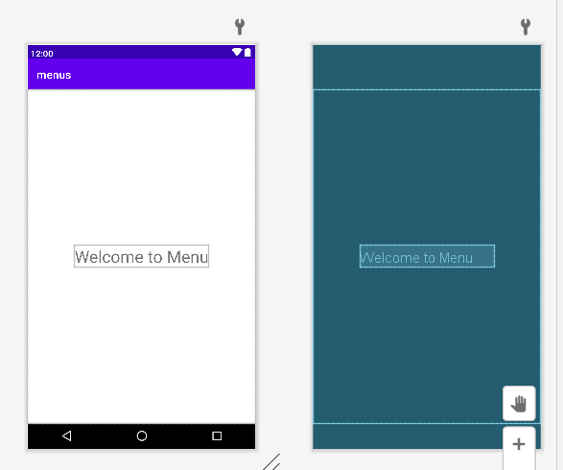

**Application Programming Interface:**

|  |  |  |  |
| --- | --- | --- | --- |
| **API / PACKAGES** | **CLASSES / INTERFACES** | **METHODS** | **DESCRIPTION** |
| import androidx.appcompat.app.AppCompatActivity; | AppCompatActivity | protected void onCreate(Bundle savedInstanceState) | onCreate(Bundle) is where you initialize your activity. When Activity is started and application is not loaded, then both onCreate() methods will be called. |
|  |  |
| import android.widget.EditText; | EditText | getText() | Determines the minimum type that getText() will return. If set, specifies that this TextView has a textual input method and should automatically capitalize what the user types. |

**Code/Implementation:**

// Develop an android application that converts text to speech.

// Project Name : ShareMyApp

/*

Lab Session No. : 09

Author : T.Avinash

Date :

Roll Number : 198W1A05C0

Description : Menuapp

Softwares required : Android Studio

Topics Covered : Options menu ,context menu

*/

***MainActivity.java***

package com.eswar.menus;  
  
import androidx.annotation.NonNull;  
import androidx.appcompat.app.AppCompatActivity;  
import androidx.appcompat.view.menu.MenuBuilder;  
  
import android.annotation.SuppressLint;  
import android.os.Bundle;  
import android.view.Menu;  
import android.view.MenuInflater;  
import android.view.MenuItem;  
import android.widget.Toast;  
  
public class MainActivity extends AppCompatActivity {  
  
 @Override  
 protected void onCreate(Bundle savedInstanceState) {  
 super.onCreate(savedInstanceState);  
 setContentView(R.layout.*activity_main*);  
 }  
 @SuppressLint("RestrictedAPI")  
 @Override  
 public boolean onCreateOptionsMenu(Menu menu) {  
 MenuInflater inflater=getMenuInflater();  
 inflater.inflate(R.menu.menu_options,menu);  
 MenuBuilder mn=(MenuBuilder) menu;  
 mn.setOptionalIconsVisible(true);  
 return true;  
 }  
  
 @Override  
 public boolean onOptionsItemSelected(@NonNull MenuItem item) {  
 Toast.*makeText*(this, "Select Item: "+item.getTitle(), Toast.*LENGTH_SHORT*).show();  
 switch (item.getItemId())  
 {  
 case R.id.upload:  
 Toast.*makeText*(this, "File Uploaded "+item.getTitle(), Toast.*LENGTH_SHORT*).show();  
 return true;  
 case R.id.download:  
 Toast.*makeText*(this, "File downloaded "+item.getTitle(), Toast.*LENGTH_SHORT*).show();  
 return true;  
 case R.id.share:  
 Toast.*makeText*(this, "File shared "+item.getTitle(), Toast.*LENGTH_SHORT*).show();  
 return true;  
 case R.id.exit:  
 System.*exit*(0);  
 case R.id.settings:  
 Toast.*makeText*(this, "Clicked on settings "+item.getTitle(), Toast.*LENGTH_SHORT*).show();  
 return true;  
 default:  
 return super.onOptionsItemSelected(item);  
 }  
  
 }  
}

*Activity_main.xml:*

*<?*xml version="1.0" encoding="utf-8"*?>*<androidx.constraintlayout.widget.ConstraintLayout xmlns:android="http://schemas.android.com/apk/res/android"  
 xmlns:app="http://schemas.android.com/apk/res-auto"  
 xmlns:tools="http://schemas.android.com/tools"  
 android:layout_width="match_parent"  
 android:layout_height="match_parent"  
 tools:context=".MainActivity">  
  
 <TextView  
 android:layout_width="wrap_content"  
 android:layout_height="wrap_content"  
 android:text="Welcome to Menu"  
 android:textSize="30dp"  
 app:layout_constraintBottom_toBottomOf="parent"  
 app:layout_constraintLeft_toLeftOf="parent"  
 app:layout_constraintRight_toRightOf="parent"  
 app:layout_constraintTop_toTopOf="parent" />  
  
</androidx.constraintlayout.widget.ConstraintLayout>

**menu_options.xml**

*<?*xml version="1.0" encoding="utf-8"*?>*<menu xmlns:android="http://schemas.android.com/apk/res/android"  
 xmlns:app="http://schemas.android.com/apk/res-auto">  
 <item  
 android:id="@+id/share"  
 android:icon="@drawable/ic_share"  
 android:title="Share"/>  
 <item  
 android:id="@+id/upload"  
 android:icon="@drawable/ic_upload"  
 android:title="Upload"/>  
 <item  
 android:id="@+id/download"  
 android:icon="@drawable/ic_download"  
 android:title="Download"/>  
 <item  
 android:id="@+id/settings"  
 android:icon="@drawable/ic_settings"  
 android:title="Settings"/>  
 <item  
 android:id="@+id/exit"  
 android:icon="@drawable/ic_exit"  
 android:title="Exit"/>  
</menu>

**ic_download.xml**

<vector xmlns:android="http://schemas.android.com/apk/res/android"  
 android:width="24dp"  
 android:height="24dp"  
 android:viewportWidth="24"  
 android:viewportHeight="24">  
 <path  
 android:pathData="M17.6,11.48 L19.44,8.3a0.63,0.63 0,0 0,-1.09 -0.63l-1.88,3.24a11.43,11.43 0,0 0,-8.94 0L5.65,7.67a0.63,0.63 0,0 0,-1.09 0.63L6.4,11.48A10.81,10.81 0,0 0,1 20L23,20A10.81,10.81 0,0 0,17.6 11.48ZM7,17.25A1.25,1.25 0,1 1,8.25 16,1.25 1.25,0 0,1 7,17.25ZM17,17.25A1.25,1.25 0,1 1,18.25 16,1.25 1.25,0 0,1 17,17.25Z"  
 android:fillColor="#FF000000"/>  
</vector>

**ic_exit.xml**

<vector android:height="24dp" android:tint="#FF4545"  
 android:viewportHeight="24" android:viewportWidth="24"  
 android:width="24dp" xmlns:android="http://schemas.android.com/apk/res/android">  
 <path android:fillColor="@android:color/white" android:pathData="M10.09,15.59L11.5,17l5,-5 -5,-5 -1.41,1.41L12.67,11H3v2h9.67l-2.58,2.59zM19,3H5c-1.11,0 -2,0.9 -2,2v4h2V5h14v14H5v-4H3v4c0,1.1 0.89,2 2,2h14c1.1,0 2,-0.9 2,-2V5c0,-1.1 -0.9,-2 -2,-2z"/>  
</vector>

**ic_settings.xml**

<vector android:height="24dp" android:tint="#FF4545"  
 android:viewportHeight="24" android:viewportWidth="24"  
 android:width="24dp" xmlns:android="http://schemas.android.com/apk/res/android">  
 <path android:fillColor="@android:color/white" android:pathData="M19.14,12.94c0.04,-0.3 0.06,-0.61 0.06,-0.94c0,-0.32 -0.02,-0.64 -0.07,-0.94l2.03,-1.58c0.18,-0.14 0.23,-0.41 0.12,-0.61l-1.92,-3.32c-0.12,-0.22 -0.37,-0.29 -0.59,-0.22l-2.39,0.96c-0.5,-0.38 -1.03,-0.7 -1.62,-0.94L14.4,2.81c-0.04,-0.24 -0.24,-0.41 -0.48,-0.41h-3.84c-0.24,0 -0.43,0.17 -0.47,0.41L9.25,5.35C8.66,5.59 8.12,5.92 7.63,6.29L5.24,5.33c-0.22,-0.08 -0.47,0 -0.59,0.22L2.74,8.87C2.62,9.08 2.66,9.34 2.86,9.48l2.03,1.58C4.84,11.36 4.8,11.69 4.8,12s0.02,0.64 0.07,0.94l-2.03,1.58c-0.18,0.14 -0.23,0.41 -0.12,0.61l1.92,3.32c0.12,0.22 0.37,0.29 0.59,0.22l2.39,-0.96c0.5,0.38 1.03,0.7 1.62,0.94l0.36,2.54c0.05,0.24 0.24,0.41 0.48,0.41h3.84c0.24,0 0.44,-0.17 0.47,-0.41l0.36,-2.54c0.59,-0.24 1.13,-0.56 1.62,-0.94l2.39,0.96c0.22,0.08 0.47,0 0.59,-0.22l1.92,-3.32c0.12,-0.22 0.07,-0.47 -0.12,-0.61L19.14,12.94zM12,15.6c-1.98,0 -3.6,-1.62 -3.6,-3.6s1.62,-3.6 3.6,-3.6s3.6,1.62 3.6,3.6S13.98,15.6 12,15.6z"/>  
</vector>

**ic_share.xml**

<vector android:height="24dp" android:tint="#FF4545"  
 android:viewportHeight="24" android:viewportWidth="24"  
 android:width="24dp" xmlns:android="http://schemas.android.com/apk/res/android">  
 <path android:fillColor="@android:color/white" android:pathData="M18,16.08c-0.76,0 -1.44,0.3 -1.96,0.77L8.91,12.7c0.05,-0.23 0.09,-0.46 0.09,-0.7s-0.04,-0.47 -0.09,-0.7l7.05,-4.11c0.54,0.5 1.25,0.81 2.04,0.81 1.66,0 3,-1.34 3,-3s-1.34,-3 -3,-3 -3,1.34 -3,3c0,0.24 0.04,0.47 0.09,0.7L8.04,9.81C7.5,9.31 6.79,9 6,9c-1.66,0 -3,1.34 -3,3s1.34,3 3,3c0.79,0 1.5,-0.31 2.04,-0.81l7.12,4.16c-0.05,0.21 -0.08,0.43 -0.08,0.65 0,1.61 1.31,2.92 2.92,2.92 1.61,0 2.92,-1.31 2.92,-2.92s-1.31,-2.92 -2.92,-2.92z"/>  
</vector>

**ic_upload.xml**

<vector android:height="24dp" android:tint="#FF4545"  
 android:viewportHeight="24" android:viewportWidth="24"  
 android:width="24dp" xmlns:android="http://schemas.android.com/apk/res/android">  
 <path android:fillColor="@android:color/white" android:pathData="M19.35,10.04C18.67,6.59 15.64,4 12,4 9.11,4 6.6,5.64 5.35,8.04 2.34,8.36 0,10.91 0,14c0,3.31 2.69,6 6,6h13c2.76,0 5,-2.24 5,-5 0,-2.64 -2.05,-4.78 -4.65,-4.96zM14,13v4h-4v-4H7l5,-5 5,5h-3z"/>  
</vector>

**Output:**

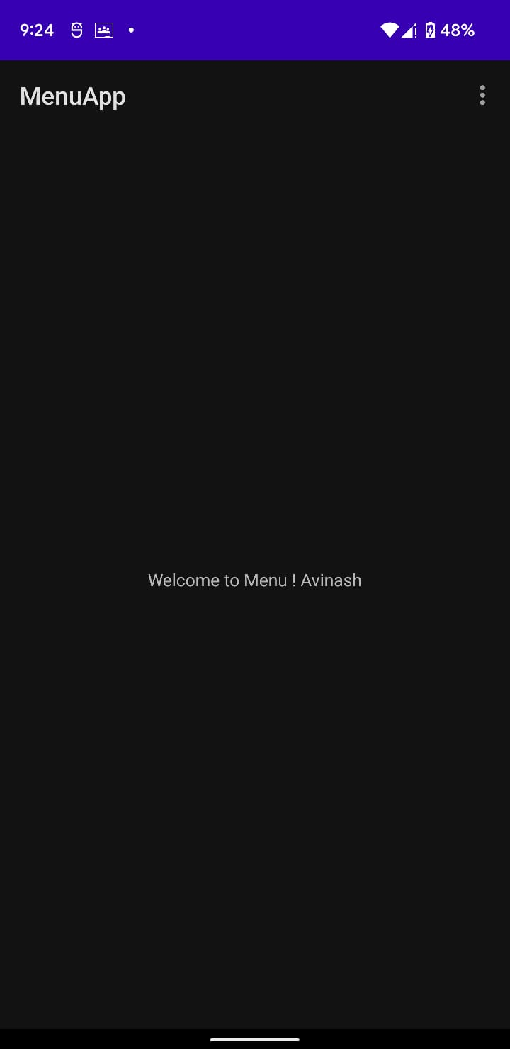 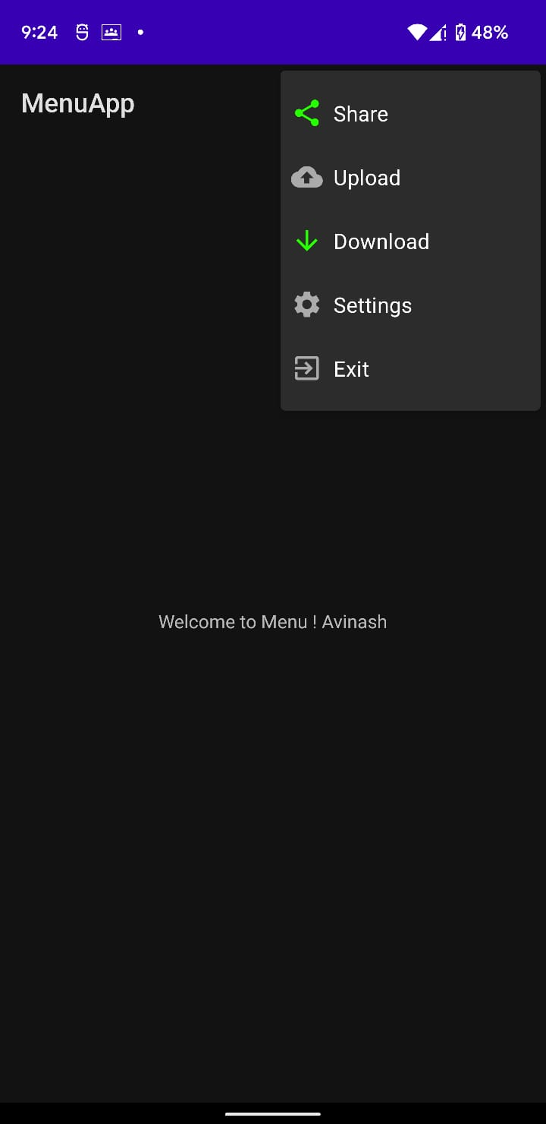

**Result:**

Demonstration of the Menus app is done successfully.